Employee – VIP Information

Logging in to VIP:
- Your manager or hiring department will provide you with your staff account. If you are student and have never worked at Trent before, an email will be sent to your student email from IT outlining the steps to activate your staff account once your hiring paperwork is processed by Payroll.
- If you have not received your staff account, please ask your manager or hiring department to request one from IT on your behalf.
- Once you have your STAFF email account, login to MyTrent. Note- students cannot access VIP using their student email account.
- To access VIP, go to Support Human Resources/PayrollVIP Timesheet. Note – you may wish to drag the icon to your short cut menu for faster access in the future.

VIP Training:
- Visit the HR VIP website and review the training/instructions on navigating VIP, including:
  - How to access your paystub
  - How to submit timesheet hours
  - And review important timesheet deadlines
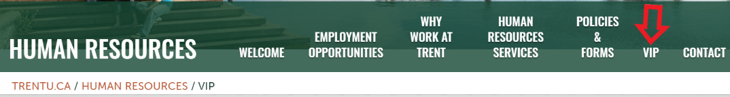
- Attend a VIP Employee training session with HR. The schedule of training will be available at www.trentu.ca/humanresources/vip

Employee Responsibilities in VIP:
- If you are an hourly paid timesheet employee, it is your responsibility to submit all hours worked in VIP at the end of each week, no later than Monday at Noon for the previous week, in order to be paid.
- Employees are not able to enter time worked in previous weeks or do a lump sum payment for hours worked, as there are tax/year-end implications, as well as employment insurance/WSIB liabilities.
- It is important to enter accurate information in to VIP, including making special note of selecting correct dates, start and end times, AM or PM, transaction codes, and the correct position, if you hold more than one position at the university.

Employee VIP Quick Reference:
Update Address/Phone Number/Emergency Contact: Employee Portal My File
Paystubs: Employee Portal My Pay Pay Stub (Downloadable)
T4’s: Employee Portal My Pay Year End Information
Timesheet: Employee Portal My Pay Timesheet
Hours Worked / Leaves: Employee Portal My Schedule Leave Requests

